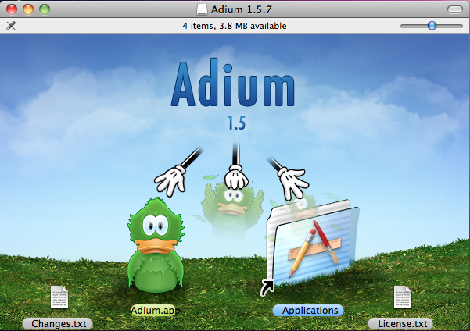
HOWTO: Instant Message Encryption with OTR

Purpose: This guide attempts to explain how to install and use Off-The-Record (OTR) messaging and a chat program to send encrypted messages over most popular instant messaging (IM) services including AIM, Google Talk, MSN, and Yahoo.

Software:
Windows users will need:
- Off-the-Record Messaging (OTR)– open-source library that does the behind-the-scenes work of encrypting and decrypting messages. (https://otr.cypherpunks.ca/index.php)
- Pidgin – open-source Instant Messaging (IM) program (https://www.pidgin.im/download/windows/)
OS X users will need:
- Adium – open-source Instant Messaging (IM) program that already includes support for OTR
(https://adium.im/)

Nutshell:
First, we will install the software. For Windows users that means we will install OTR and Pidgin. For OS X users, we will just need Adium.

Second, we will set up the software to use your existing IM account.

Third, we will test the software to make sure it is configured correctly.

That's it, you are now able to chat in private!

Part I: Install Software
- OS X
  - Obtain Adium from its website, https://adium.im/, or find the installation file on this CD.
  - Install the software by double-clicking Adium_1.5.7.dmg. You should see a window similar to the one on the right. Drag the Adium icon over the Applications folder icon and drop it there.
  - Adium is now installed in your Applications folder. Please proceed to Part II: Configure Software

- WINDOWS
  - Obtain Pidgin from its website https://pidgin.im/, or find the installation file on this CD.
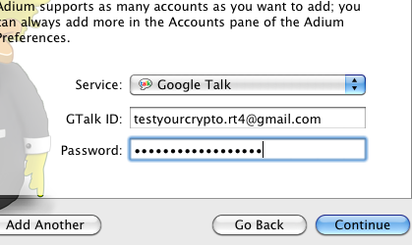
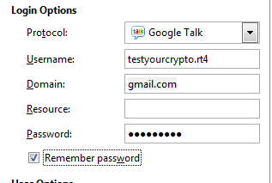
  - Install the software by double-clicking pidgin-2.10.7.exe (or pdigin-2.10.7-offline.exe). Select a language and press OK. The default options are okay. You can click Next > until the installation completes.
  - Obtain OTR Plug-in for Pidgin from its website, https://otr.cypherpunks.ca/index.php, or find the installation file on this CD. Please note that one this website, the download you looks like:
Primary download: Win32 installer for pidgin-otr 4.0.0-1 (sig) [other downloads]
  - Install OTR Plug-in for Pidgin by double-clicking pidgin-otr-4.0.0-1.exe. Just click Next > until the installation completes, there are no options to change here.

Part II: Configure Software
- OS X
  - Run Adium, located in your Applications folder
  - Setup your account. Click Continue on the first page. Then select the type of account you are using in the Service dropdown menu. Type in your username and password for that account, then click Continue.
  - Click Adium in the menu bar and click Preferences. Review the following items:
    - On the Advanced tab, click the Encryption sub-tab on the left side. Select your account in the pane on the right, then click Generate.
    - On the Accounts tab, you may want to deselect “Log OTR-secured chats”
  - Adium is now set up for encrypted messaging. Remember, the person you message must have OTR (or a program like Adium that supports it) installed to decrypt your messages.
- WINDOWS
  - Run Pidgin by clicking the Start Menu or orb, then Programs (or All Programs), then Pidgin.
  - Pidgin should prompt you to add your account. If not, click Accounts in the menu bar, then click Manage Accounts. Then click the Add... button.
  - Select the type of IM account you want to use under Protocol. Then type in your username and password, and press Save.
  - Your account should now be connected and your buddy list should begin to load. Next we configure OTR for encryption.
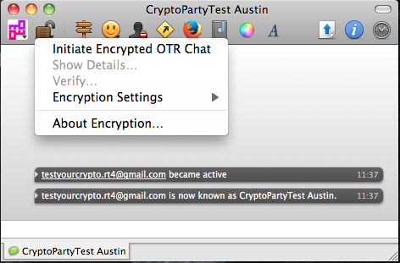
  - In the Pidgin Buddy List window, select the Tools menu, then click Plugins. Scroll down until you find the Off-the-Record Messaging plugin. Check the box next to the plugin, and then click Configure Plugin.
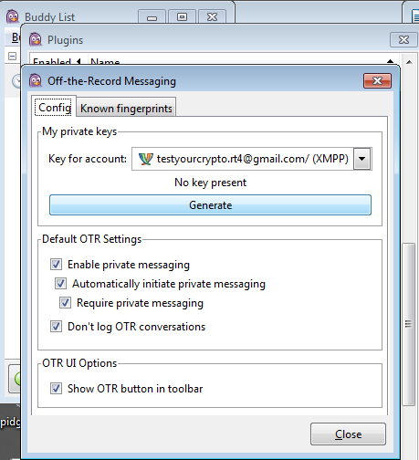
  - In the Off-The-Record Messaging Config screen, select the account you want to use encryption with, and then click Generate.
  - Choose your Default OTR Settings to control how messages are sent by default. You will need to have “Enable private messaging” enabled, and I recommend also selecting “Automatically initiate private messaging” so Pidgin will encrypt it automatically as long as the person you are messaging has OTR installed. If you want your account to only send encrypted messages, also select “Require private messaging”. Finally, I recommend selecting “Don't log OTR conversations” to keep your messages from prior conversations from being read. When you have finished selecting your options, click Close.
  - Pidgin is now set up to use OTR to encrypt your messages. Remember, the person you message must also have OTR to be able to decrypt the message.

Part III: Test Software
- OS X
  - Open Adium if it is not already open. In the Contacts window, double-click the name of a contact to start a new message.
  - In the message window, click the open lock icon in the top left, and select Initiate Encrypted OTR Chat.
  - If your contact is also using OTR, your computers will exchange public keys automatically.

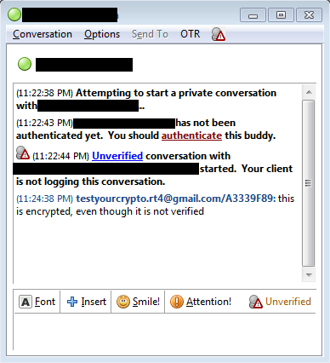
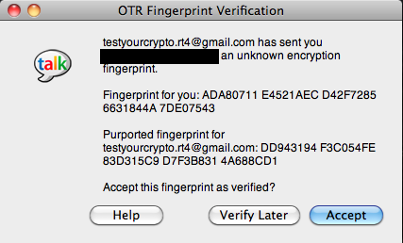
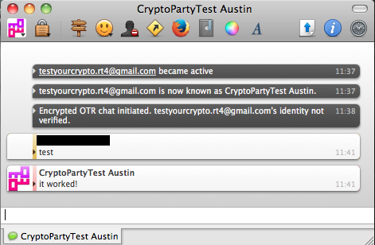
  - If this is the first time you are sending a message to that contact, the OTR Fingerprint Verification window will open, asking you to verify your contact's public key. This is asking if you trust that the person using the computer on the other end really is the person you were trying to contact. You can be more sure by asking your contact questions that only they know the answer to, or calling your contact just to confirm the keys shown. Click Accept to verify the key.
  - The lock icon in the top left should now be closed, and the chat window should show “Encrypted OTR chat initiated.”
  - You are now sending and receiving encrypted instant messages.
- WINDOWS
  - Open Pidgin if it is not already open. In the Buddy List window, double-click the name of a contact to start a new message.
  - On the right side of the chat window, above the text box at the bottom, you should see “Not Private” in red text. Click that, and select “Start private conversation”. If the person you are trying to contact has an OTR-enabled chat program, then you are ready to go.
  - If this is the first time you have sent an encrypted message to that person, Pidgin will show “Unverified” on the right side above the text box at the bottom. You will generally only need to do verification once per contact, but occaisonally you may need to verify again. If your contact is using anything other than Pidgin with the OTR plugin, you may need to select “Manual fingerprint verification”.Please see the following link for more information on verification:
https://otr-help.cypherpunks.ca/4.0.0/authenticate.php?lang=en
  - Once you have completed the above steps, including verification, the window should show “Private” on the right side above the text box at the bottom.
  - You're done. You should now be able to send and receive encrypted IMs. In the future, if the button on the right side above the bottom text box says “Not Private” or “Unverified”, repeat the steps above.

A Note on Receiving Messages (Windows and OS X):
When another person starts an encrypted chat with you, the only part of the above process that applies is the Verification part.

A Note on Privacy:
When you use these programs, the content of your messages is encrypted. However, the metadata is not encrypted. This means that your chat provider (Google, AOL, etc) can see that you sent a message, and who the message was sent from and to, as well as the date and time, your IP address, and some other information. If you do not use encryption, your chat provider will also be able to read the text content of your message.

